Tensorflow Project POC
We'll use the Bank Authentication Data Set (https://archive.ics.uci.edu/ml/datasets/banknote+authentication) from the UCI repository.
The data consists of 5 columns:
- variance of Wavelet Transformed image (continuous)
- skewness of Wavelet Transformed image (continuous)
- curtosis of Wavelet Transformed image (continuous)
- entropy of image (continuous)
- class (integer)
Where class indicates whether or not a Bank Note was authentic.

We will use Neural Networks and Deep Learning for this POC.
Download the file from the above link and save it as bank_note_data.csv
Import all needed libraries:
import pandas as pd
import numpy as np
import tensorflow as tf
import tensorflow.contrib.learn as learn
import seaborn as sns,matplotlib.pyplot as plt
%matplotlib inline

Using pandas to read in the bank_note_data.csv file
data = pd.read_csv('bank_note_data.csv')
data.info()
Checking records in dataframe
data.head()
EDA:
We'll just do a few quick plots of the data.
Creating a Countplot of the Classes ( 1 vs 0)

sns.countplot(x='Class',data=data,palette='viridis')

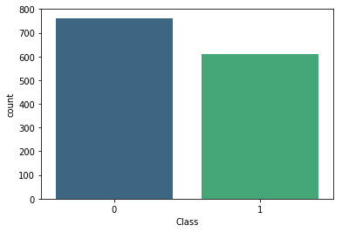

Creating a PairPlot of the Data: sns.pairplot(data=df,hue='Class',palette='viridis',)
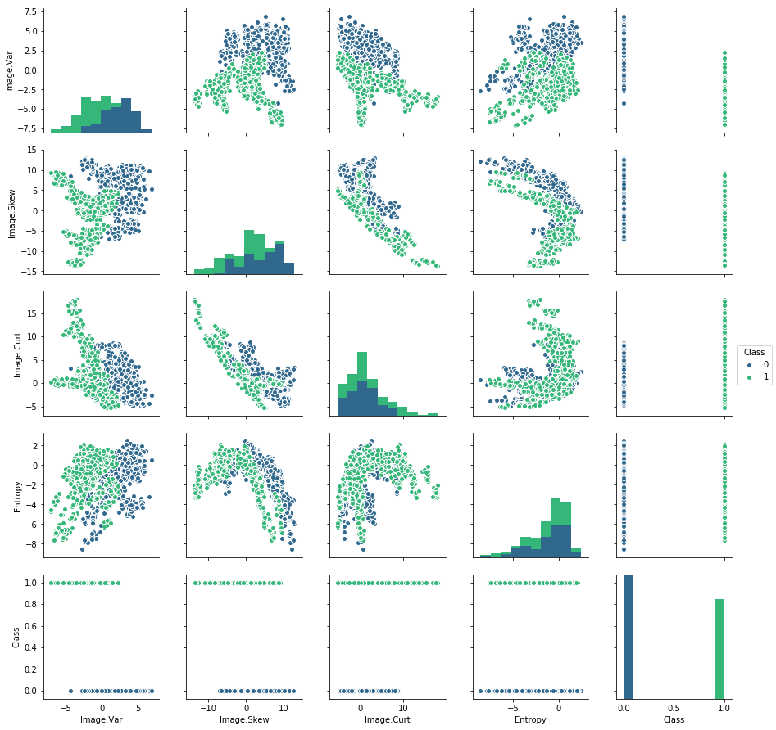
We will Standardize our data Data
Standard Scaling **
from sklearn.preprocessing import StandardScaler
Instantiating StandardScaler
scaler = StandardScaler()
Fitting scaler to the features:
scaler.fit(data.drop(‘Class’,axis=1))
Using the .transform() method to transform the features to a scaled version.
scaled_features = scalar.fit_transform(data.drop('Class',axis=1))
Converting the scaled features to a dataframe
scaled_data = pd.DataFrame(scaled_features,columns=data.columns[:-1])
creating two objects X and y which are the scaled feature values and labels respectively
X = scaled_data
y = data['Class']
We will convert X and y to numpy array from panda series in order to get it accepted by Tensorflow. We will use .as_matrix() method
X = X.as_matrix()
y = y.as_matrix()
Spliting X and y in train and test data
from sklearn.model_selection import train_test_split
X_train, X_test, y_train, y_test = train_test_split(X, y, test_size=0.3, random_state=101)
Creating an object which is a DNNClassifier from learn. Seting it to have 2 classes(0 and 1 mentioned in the provided data) and a [10,20,10] hidden unit layer structure:
my_feature_columns = [tf.contrib.layers.real_valued_column("",dimension=4)]
classifier = learn.DNNClassifier(hidden_units=[10,20,10],n_classes=2,feature_columns=my_feature_columns)
Now fitting classifier to the training data. Use steps=200 with a batch_size of 32.
classifier.fit(X_train,y_train,steps=200,batch_size=32)
Using the predict method from the classifier model to create predictions from X_test
note_predictions = list(classifier.predict(X_test))

Note: If we donot append predict method with the list then it will fails with error as :
TypeError: Expected sequence or array-like, got <class 'generator'>
Probably easiest is to just save the generator object as iterator with either as “list” or “np.array(list(“
Creating a classification report and a Confusion Matrix.
from sklearn.metrics import confusion_matrix,classification_report
print(classification_report(y_test,note_predictions))
print('\n')
print(confusion_matrix(y_test,note_predictions))
precision recall f1-score support

0 1.00 1.00 1.00 238
1 1.00 1.00 1.00 174

avg / total 1.00 1.00 1.00 412

[[238 0]
[ 0 174]]

Optional Comparison :
We have noticed extremely accurate results from the DNN model. So, we will compare this to Random Forest Classifier for a reality check!
from sklearn.ensemble import RandomForestClassifier
rfc = RandomForestClassifier(n_estimators=200)
rfc.fit(X_train,y_train)
rfc_preds = rfc.predict(X_test)
print(classification_report(y_test,rfc_preds))
print(confusion_matrix(y_test,rfc_preds))
precision recall f1-score support
precision recall f1-score support
 | precision | recall | f1-score | support
0 | 1.00 | 0.98 | 0.99 | 238
1 | 0.98 | 1.00 | 0.99 | 174
avg / total | 0.99 | 0.99 | 0.99 | 412

[[234 | 4]
[0 | 174]]

Random forest has also done very well but not as good as DNN

